Building a SOC Monitoring Environment Using Splunk SIEM
Security teams rely on centralized monitoring platforms to detect suspicious activity, investigate incidents, and maintain visibility across enterprise environments. Security Information and Event Management (SIEM) solutions play a critical role in achieving this by collecting, indexing, and analysing logs from multiple systems.
In this lab, a Security Operations monitoring environment was deployed using Splunk Enterprise to simulate how a SOC team monitors activity across multiple endpoints.
The objective of the deployment was to build an on-premises SIEM environment capable of ingesting and analysing logs from both Linux and Windows systems. This setup demonstrates how security teams can centralize log collection, monitor system activity, and perform investigations using a SIEM platform.
The deployment included:
- Installing Splunk Enterprise on a Linux host
- Deploying Splunk Universal Forwarders on endpoint systems
- Collecting Linux system logs and Windows Event Logs
- Verifying successful log ingestion through controlled test events
Once the environment was operational, test logs were generated to confirm that events were successfully transmitted, indexed, and searchable within the SIEM platform.

Alert Details
Investigation Type: SOC Infrastructure Deployment
Platform: Splunk Enterprise
Environment: Linux and Windows endpoints
Objective: Centralized log monitoring and event analysis

Monitoring Architecture
Component | Function
Splunk Enterprise | Log indexing and security event analysis
Splunk Universal Forwarder | Log collection from endpoints
Linux Syslog | Monitoring Linux system activity
Windows Event Logs | Monitoring endpoint activity
This architecture simulates a basic SOC monitoring pipeline where endpoint logs are forwarded to a centralized SIEM server for indexing and analysis.

Investigation Process

1. Splunk Installation
The SIEM server was deployed by installing Splunk Enterprise on a Linux host. The installation package was extracted and placed inside the /opt directory, which is commonly used for application installations in Linux environments.
The Splunk service was started using the following command:

./Splunk start --accept-license

During the initial startup process, an administrator account was created to manage the Splunk instance.
Once the service started successfully, the Splunk web interface became accessible through port 8000, allowing administrators to manage data ingestion, perform searches, and monitor system activity.
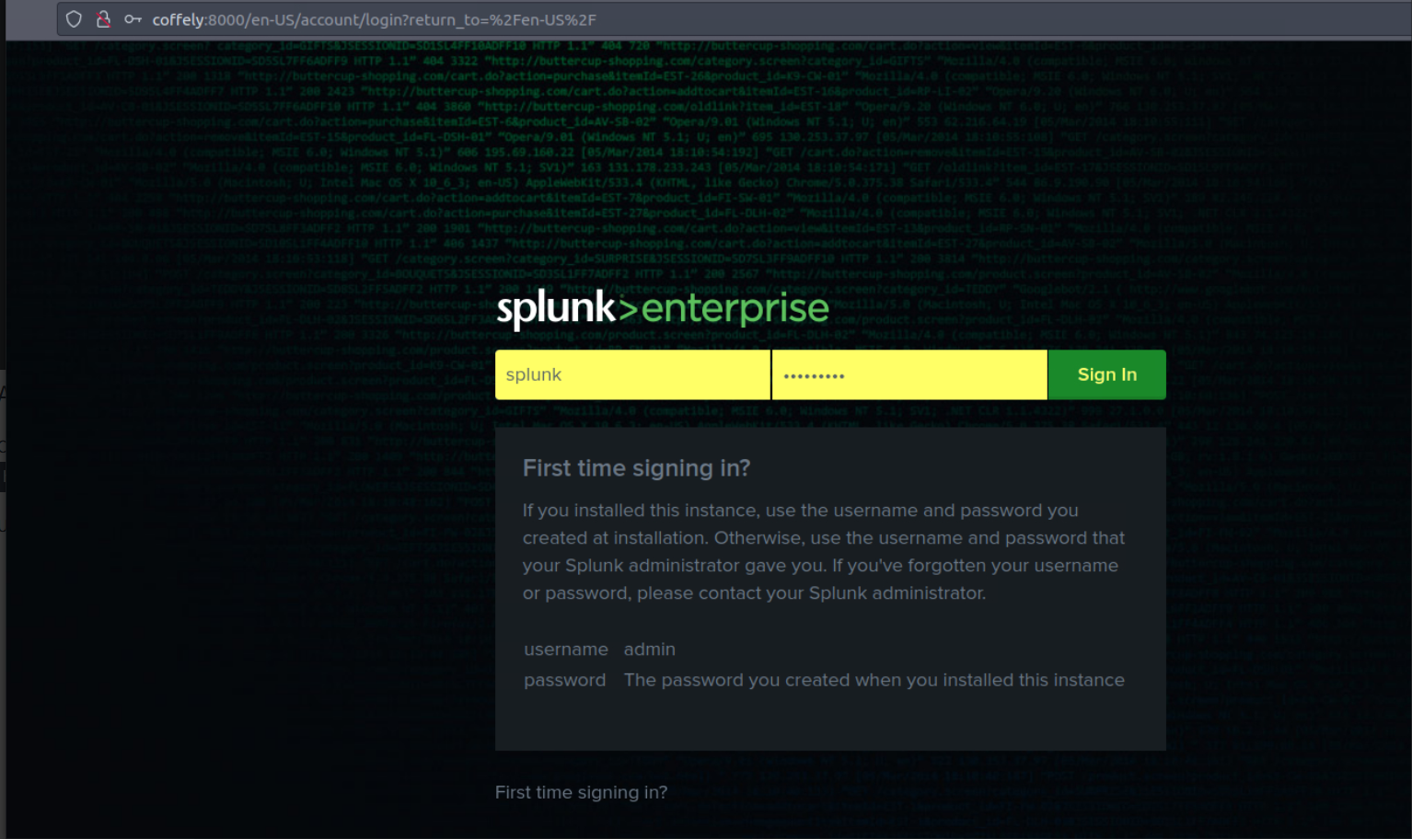
Figure 1 — Splunk Enterprise web interface accessible through port 8000 after successful installation.

Splunk CLI Management
Several command-line commands are used to manage the Splunk service from the terminal.
Command | Purpose
Splunk start | Start Splunk service
Splunk stop | Stop Splunk service
Splunk restart | Restart service after configuration changes
Splunk status | Check service status
Splunk search | Execute search queries
Using the CLI allows administrators to manage Splunk efficiently without relying solely on the web interface.
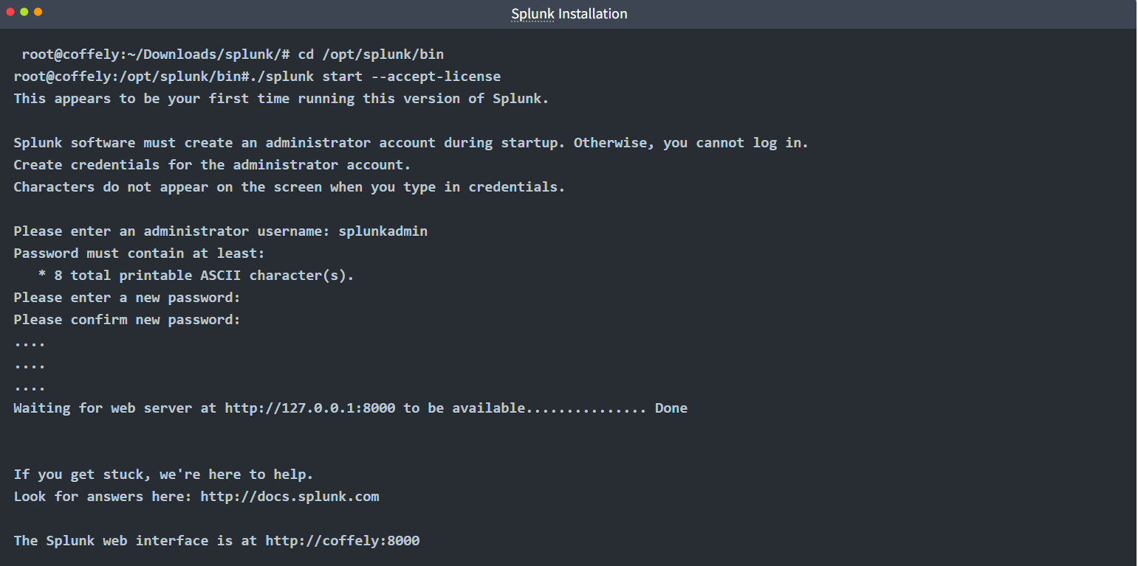
Figure 2 — Splunk service started successfully using the Linux command line interface.

Evidence & System Validation

Evidence 1 — Splunk Server Deployment
The Splunk Enterprise instance was successfully deployed and made accessible through the web interface.

http://coffely:8000

This interface provides access to dashboards, search functionality, and administrative settings used to manage the SIEM platform.
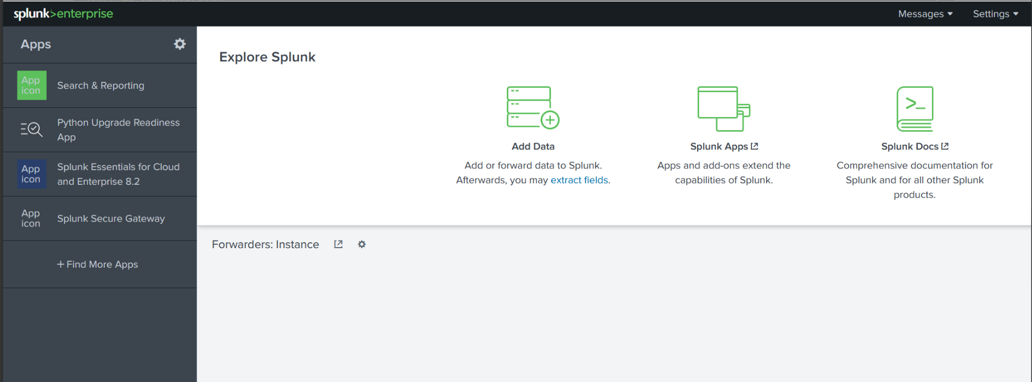
Figure 3 — Splunk Enterprise dashboard showing the central interface used for data ingestion, application management, and security monitoring.

Evidence 2 — Forwarder Configuration
To collect logs from endpoint systems, the Splunk Universal Forwarder was installed on client machines.
Universal Forwarders are lightweight agents designed to collect log data and forward it securely to a Splunk indexer.
Forwarders were configured to send logs to the SIEM server using port 9997, which is the default port used by Splunk to receive incoming data.
Example configuration command:

./Splunk add forward-server MACHINE_IP:9997

This command registers the SIEM server as the destination where collected logs should be forwarded.

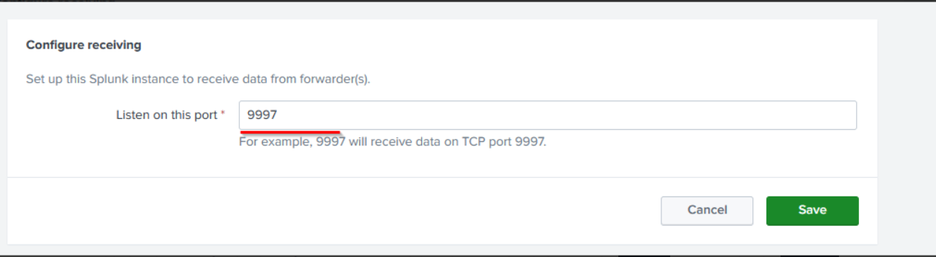
Figure 4 — Splunk receiver configuration enabling the SIEM server to collect logs from endpoint forwarders through port 9997.

Evidence 3 — Index Creation
To organize collected data, a dedicated index was created to store Linux system logs.
Index Name:

Linux_host
Indexes help Splunk administrators separate data sources and improve search efficiency.
Without a dedicated index, logs would be stored in the default main index, which can become difficult to manage in larger environments.
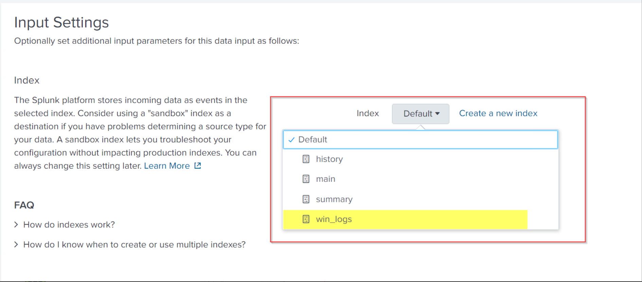
Figure 5 — Splunk index configuration used to store collected log data for monitoring and analysis.

Windows Log Integration
In addition to Linux systems, Windows endpoints were also integrated into the SIEM environment.
The Splunk Universal Forwarder was installed on a Windows host and configured to collect Windows Event Logs.
Collected logs included:
- Application Logs
- Security Logs
- System Logs
Once configured, these logs were forwarded to the Splunk indexer via port 9997, allowing the SIEM platform to monitor events across both Linux and Windows systems within a centralized interface.

Timeline Analysis
Time | Event
Splunk installation | SIEM platform deployed
Server initialization | Splunk service started
Forwarder deployment | Endpoint agents installed
Data ingestion configuration | Linux syslog monitored
Test event generated | Custom log created
Verification | Log successfully indexed

Conclusion
This lab demonstrated how a Security Operations monitoring environment can be established using a SIEM platform.
By deploying Splunk Enterprise on a central server and installing Universal Forwarders on endpoint systems, logs from multiple operating systems were successfully aggregated into a single monitoring platform.
The integration of Linux system logs and Windows Event Logs provides centralized visibility into system activity, enabling security teams to detect anomalies and investigate potential threats more efficiently.
Testing the pipeline with a generated log entry confirmed that logs were successfully collected, forwarded, and indexed within the SIEM platform.

Final Assessment
Successful SIEM Deployment — Monitoring Infrastructure Operational
The SIEM platform successfully collected and indexed logs from multiple endpoints, demonstrating the ability to support centralized monitoring and security investigations.

Recommendations
To further improve the SOC monitoring environment, several enhancements can be implemented:
- Integrate additional log sources such as firewall logs and web server logs
- Configure automated alerts for suspicious activity
- Develop dashboards to visualize security events
- Implement correlation rules for threat detection
- Perform regular log reviews to identify anomalies
Expanding the number of monitored data sources and implementing automated detections can significantly improve an organization’s ability to detect and respond to security incidents.

